Mohamed Ahmed Mohamed Abd Elgani
Lab 3
==========================================
1-2 Create a user account with the following attribute
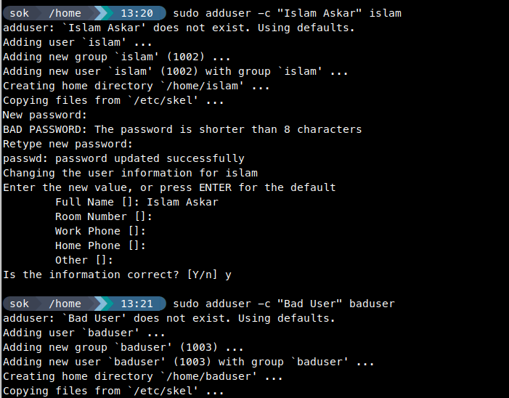
3-

4 -


5-Add islam user to the pgroup group as a supplementary group

6-Modify the password of islam's account to password
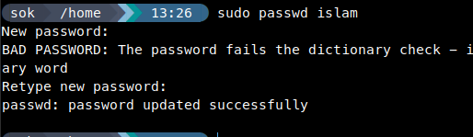

7- Modify islam's account so the password expires after 30 days


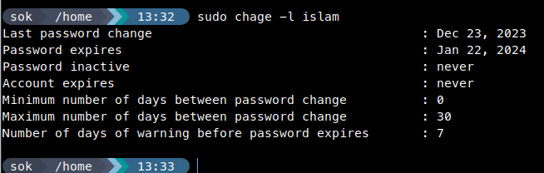
8-Lock bad user account so he can't log in
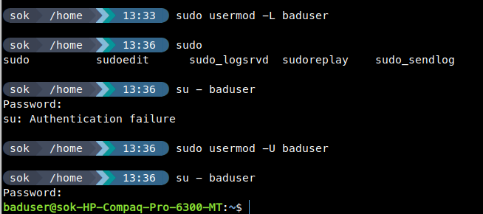

9.Delete bad user account

10. Delete the supplementary group called badgroup.

13-Create a folder called myteam in your home directory and change its permissions to
read only for the owner.
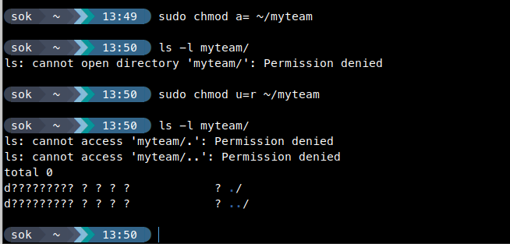
14-Log out and log in by another user

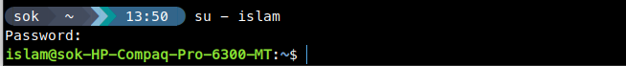

15-Try to access (by cd command) the folder (myteam)
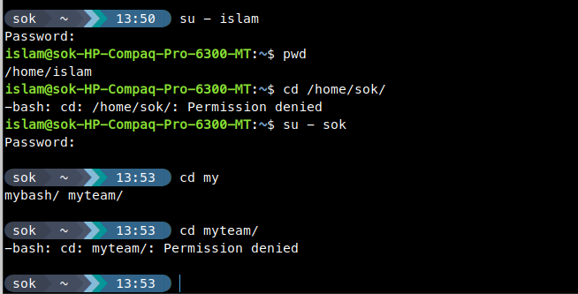


16. Using the command Line
a-
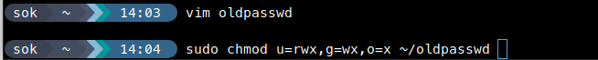


b-

c- For files its 666 and Dirs is 777 ===> that means the dir got the x permission and the file is not.

d-
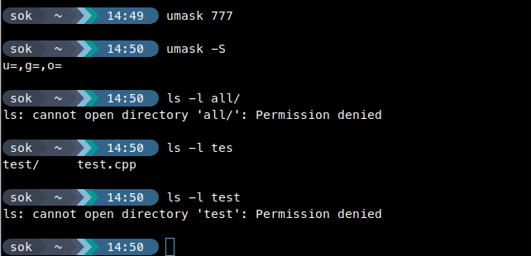

17 -What are the minimum permission needed for:
For | Source Permissions | Target Permissions
Copy a directory | rx | wx
Copy a file | r | wx
Delete a file | w | w
Change to a directory | x
List a directory content | r
View a file content | r
Modify a file content | w

18-create a file with permission 444.
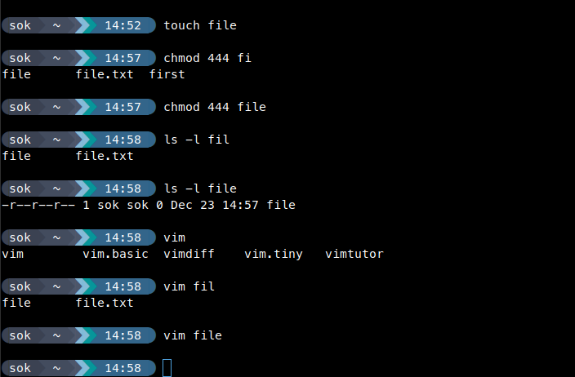

19- x for files make it executable
x for dirs allow to cd into it also cp mv rm

